

NEWSLETTER

This newsletter shares clear, practical updates on real estate law, compliance, and due diligence, helping buyers and property owners make informed decisions. We cover legal changes, registration updates, and buyer-focused insights to help you avoid risks and navigate property transactions with confidence.

🔹 Can tenants claim ownership after decades of occupancy? SC clarifies

The Supreme Court has clarified that tenants cannot claim ownership of a property simply because they have occupied it for decades. In a case involving a shop rented in 1953, the court ordered eviction of tenants who had stopped paying rent in 2000 but continued occupying the premises. It ruled that tenancy is based on the landlord’s permission, so long-term possession does not convert into ownership or “adverse possession.” The court also directed the tenants to clear rent arrears accumulated over more than 25 years.
Read More

🔹 Understanding RERA 2.0: 5 important changes every homebuyer and developer must know

RERA 2.0 introduces stronger rules to improve transparency and protect homebuyers in India’s real estate market. The key changes include stricter penalties for delayed projects, mandatory third-party audits of project funds, faster digital complaint resolution, wider coverage of ongoing projects under RERA, and standardized builder-buyer agreements to reduce unfair clauses. These reforms aim to increase accountability for developers and give homebuyers greater legal protection.
Read More


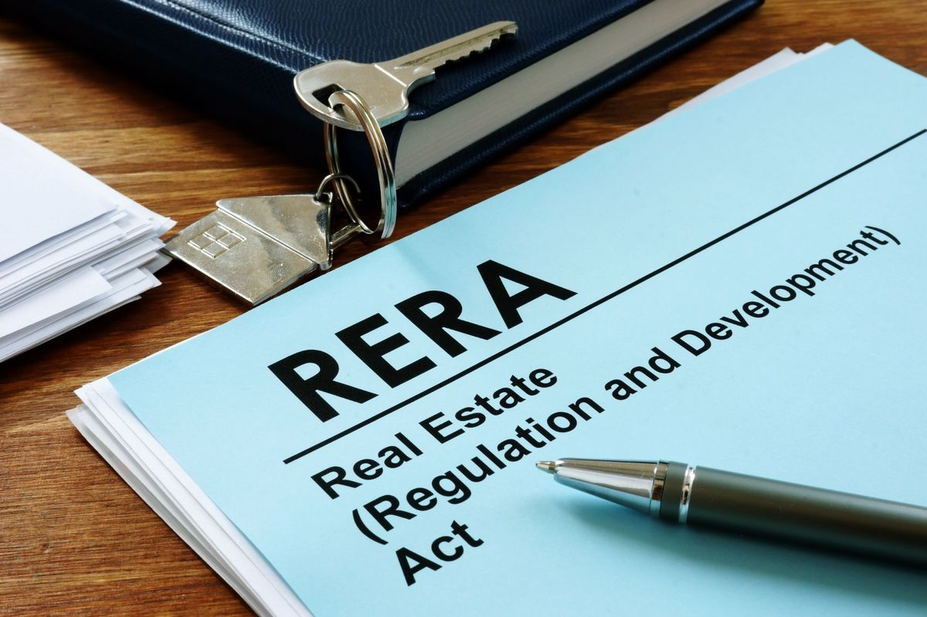

🔹 There is no repugnancy between provisions of RERA and Karnataka Apartment Ownership Act: Karnataka High Court

The Karnataka High Court has ruled that there is no conflict (“repugnancy”) between the Real Estate (Regulation and Development) Act (RERA) and the Karnataka Apartment Ownership Act (KAOA). The court clarified that both laws serve different but complementary purposes—RERA regulates developers and protects homebuyers during project development, while KAOA governs the ownership and management of completed apartments by owners’ associations. Therefore, both laws can operate together without overriding each other.
Read More

🔹 Parking Details to Become Compulsory for Homebuyers Under Karnataka RERA Guidelines

The Karnataka Real Estate Regulatory Authority (K-RERA) plans to make it mandatory for builders to clearly disclose parking details in allotment letters and sale agreements for residential projects. Developers will have to specify the exact parking slot number, type (covered/open/basement), size, and location, and attach an approved parking layout plan to the agreement.

The move aims to reduce disputes over parking allocation, a common complaint among homebuyers, and improve transparency in property transactions.
Read More

🔹 Living on a property for decades? Courts say possession alone doesn’t give you ownership without proving adverse possession

Courts in India have clarified that living on a property for decades does not automatically give someone ownership rights. To claim ownership without a title, a person must prove “adverse possession”, which requires showing that the occupation was open, continuous, exclusive, and against the true owner’s rights for the legally prescribed period (usually 12 years for private property).
Mere long-term occupation, especially if it began with the owner’s permission—such as in the case of tenants or caretakers—cannot be used to claim ownership. Courts emphasize that adverse possession is an exception and must be proved with strong evidence, not assumed from long stay alone.
Read More

🔹 How To Determine If An Agreement Creates A License Or Lease? Supreme Court Clarifies
The Supreme Court has clarified that to determine whether an agreement is a lease or a license, courts must look at the actual intention of the parties and the rights given in the agreement, not just the title of the document. If the agreement gives exclusive possession and creates an interest in the property, it is a lease; if it only allows temporary use without transferring any property rights, it is a license.
Read More

🔹 RERA pulls up builder for handing over flats without OC
RERA pulled up a builder for handing over flats without obtaining the mandatory Occupancy Certificate (OC). It held that possession without OC is illegal and directed the builder to obtain the OC within a specified time, bear maintenance costs until then, and rectify deficiencies. The case reinforces that OC is essential before handing over possession to buyers.
Read More



About Proplex:

Proplex Consulting LLP, Bengaluru, provides end-to-end legal support for property transactions, including title verification, scrutiny of ownership and revenue records, drafting and registration of Sale Deeds, Agreements, Gift/Release Deeds, Khata transfer/Registration and Conversion, B-Khata to A-Khata services, POA adjudication, and BESCOM/BBMP-related compliances. The Firm liaises with Sub-Registrar Offices, BBMP, BDA, BESCOM, and banks to ensure lawful, accurate, and timely completion of all property documentation and registration processes, with our lawyers assisting you at each step of the process.

In the event that any further clarification is required, you are requested to contact us at the number specified herein below.

Email: info@proplex.co.in

Linkedln

Phone: +91 - 96110 52449

Address: 1st Floor, SGR Plaza, No 43, HAL Old Airport Rd, above Federal Bank, Marathahalli Village, Marathahalli, Bengaluru, Karnataka 560037

